**Exercise 1: Control Structures**

First, we create Tables in a Schema.  
**Step 1: Create Tables**

-- Customers Table

CREATE TABLE Customers (

Customer_Id INT PRIMARY KEY,

Name VARCHAR(100),

Age INT,

Balance DECIMAL(10,2),

IsVIP BOOLEAN DEFAULT FALSE

);

-- Loans Table

CREATE TABLE Loans (

LoanID INT PRIMARY KEY,

Customer_Id INT,

InterestRate DECIMAL(5,2),

DueDate DATE,

FOREIGN KEY (Customer_Id) REFERENCES Customers(Customer_Id)

);

**Step 2: Inserting values in Tables**

INSERT INTO Customers (Customer_Id, Name, Age, Balance)

VALUES

(1, 'Alice', 65, 15000.00),

(2, 'Bob', 45, 8000.00),

(3, 'Charlie', 70, 12000.00),

(4, 'David', 30, 3000.00),

(5, 'Eve', 62, 9500.00);

INSERT INTO Loans (LoanID, Customer_Id, InterestRate, DueDate)

VALUES

(101, 1, 7.5, CURDATE() + INTERVAL 15 DAY),

(102, 2, 8.0, CURDATE() + INTERVAL 40 DAY),

(103, 3, 6.5, CURDATE() + INTERVAL 10 DAY),

(104, 4, 7.0, CURDATE() - INTERVAL 5 DAY),

(105, 5, 9.0, CURDATE() + INTERVAL 25 DAY);

**Step 3: Create Procedure 1 – Discount for Age > 60**

DELIMITER //

CREATE PROCEDURE DiscountSeniorInterest()

BEGIN

-- Apply 1% discount to loan interest for customers above 60

UPDATE Loans

SET InterestRate = InterestRate - 1

WHERE Customer_Id IN (

SELECT Customer_Id FROM Customers WHERE Age > 60

);

END //

DELIMITER ;

-----------------------------------------------------------------------------------------------------------------------------------------------------------

Output Demo of before and after procedure implementation using command: CALL DiscountSeniorInterest();

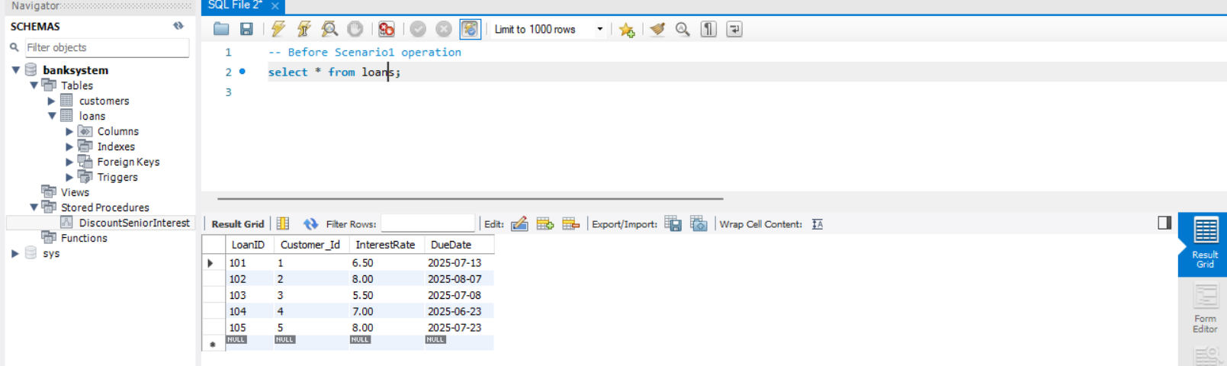

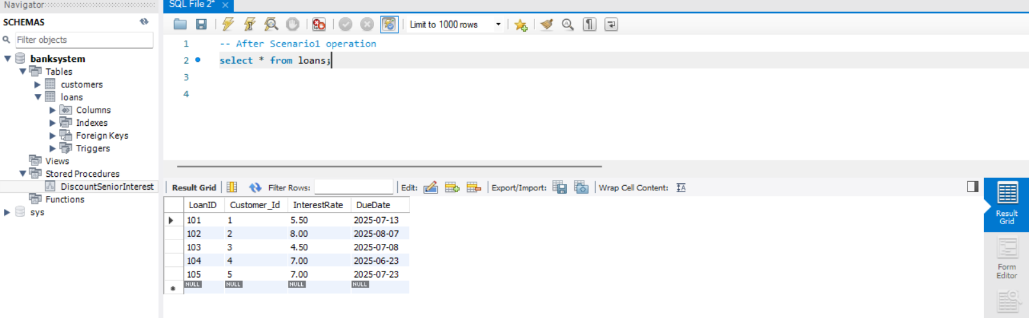

**Step 4: Create Procedure 2 – Promote to VIP**

DELIMITER //

CREATE PROCEDURE PromoteToVIP()

BEGIN

-- Promote customers with balance > 10000 to VIP

UPDATE Customers

SET IsVIP = TRUE

WHERE Customer_Id IN (

SELECT Customer_Id FROM (

SELECT Customer_Id FROM Customers WHERE Balance > 10000

) AS temp

);

END //

DELIMITER ;

Output Demo of before and after procedure implementation using sql command:

SET SQL_SAFE_UPDATES = 0;

CALL PromoteToVIP();

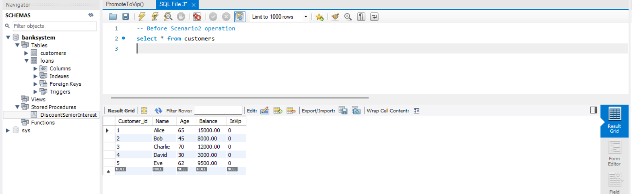

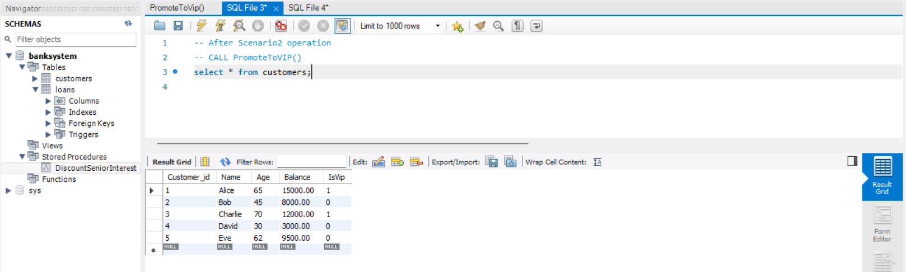

**Step 5: Create Procedure 3 – Loan Reminders for Next 30 Days**

DELIMITER //

CREATE PROCEDURE ShowLoanReminders()

BEGIN

-- Show reminders for loans due in the next 30 days

SELECT

CONCAT('Reminder: Dear ', C.Name,

', your loan (ID: ', L.LoanID,

') is due on ', DATE_FORMAT(L.DueDate, '%d-%b-%Y')) AS ReminderMessage

FROM Loans L

JOIN Customers C ON L.Customer_Id = C.Customer_Id

WHERE L.DueDate BETWEEN CURDATE() AND (CURDATE() + INTERVAL 30 DAY);

END //

DELIMITER ;

Output Demo after procedure implementation using command: CALL ShowLoanReminders();

